Summary:
Critical: Internal Server Error (500) on /pos/v1/private/get-rewards-to-date
A critical vulnerability was discovered where the API endpoint /pos/v1/private/get-rewards-to-date returns a 500 Internal Server Error when receiving a GET request with authentication parameters in the query string, despite the endpoint expecting POST requests with JSON body authentication. This indicates improper input validation and exception handling that could potentially be exploited for denial of service, information disclosure, or in more severe cases, remote code execution.

Steps To Reproduce:
- Create legit crypto.com account.
- Generate an API key.
- Conduct research on API endpoints and what proper requests look like.
- Do probing requests using Burp Suite Community and Postman to understand and study responses.
- Capture a valid authentication signature from a working API request (e.g., from private/get-account-summary). Like sending a POST request to https://api.crypto.com/pos/v1/private/get-rewards-to-date.
- Construct a GET request to the vulnerable endpoint with authentication parameters in the query string:
GET /pos/v1/private/get-rewards-to-date?api_key=GbnZUX7LobUtb4gKsYW9F3&nonce=1771312298283&sig=0cba33ef28dee61aa6983b28d0d3720d7023b9870be65f55d396d104ac07ba1a HTTP/2
Host: api.crypto.com
X-HackerOne-Research: isiahjonesstem
- Send the request to the server
- Observe the response: The server returns HTTP/2 500 Internal Server Error with a JSON error object containing timestamp, status, error message, and path information

Proof of Concept:
Burp community repeater request:
GET /pos/v1/private/get-rewards-to-date?api_key=GbnZUX7LobUtb4gKsYW9F3&nonce=1771312298283&sig=0cba33ef28dee61aa6983b28d0d3720d7023b9870be65f55d396d104ac07ba1a HTTP/2
Host: api.crypto.com
X-Hackerone-Research: isiahjonesstem
Burp community repeater response:
HTTP/2 500 Internal Server Error
Date: Tue, 17 Feb 2026 06:29:29 GMT
Content-Type: application/json
Server: cloudflare
Cf-Ray: 9cf33b0addaef24a-IAD
Cf-Cache-Status: DYNAMIC
Vary: Origin, Access-Control-Request-Method, Access-Control-Request-Headers
Set-Cookie: __cf_bm=ahB8bwUw.7H1Txxog3v7osuVysdaxrKu47IkMlcKh2M-1771309769-1.0.1.1-ZUkH2vtiVTpyxaDqSig9u.9l9DQT2txwdhWowv4JYjbaFXT.592QnOP_gUbGU1O2okHXZuR1HktmyRoRdSniG3setzHNpN5eTmCHJPVOaIE; path=/; expires=Tue, 17-Feb-26 06:59:29 GMT; domain=.crypto.com; HttpOnly; Secure
Set-Cookie: _cfuvid=FwcbIMH2wgIftur5zATYv3mVNCIQ_7rTP4uubqoivtw-1771309769665-0.0.1.1-604800000; path=/; domain=.crypto.com; HttpOnly; Secure; SameSite=None
Alt-Svc: h3=":443"; ma=86400
{"timestamp":"2026-02-17T06:29:29.583+00:00","status":500,"error":"Internal Server Error","path":"/pos/v1/private/get-rewards-to-date"}

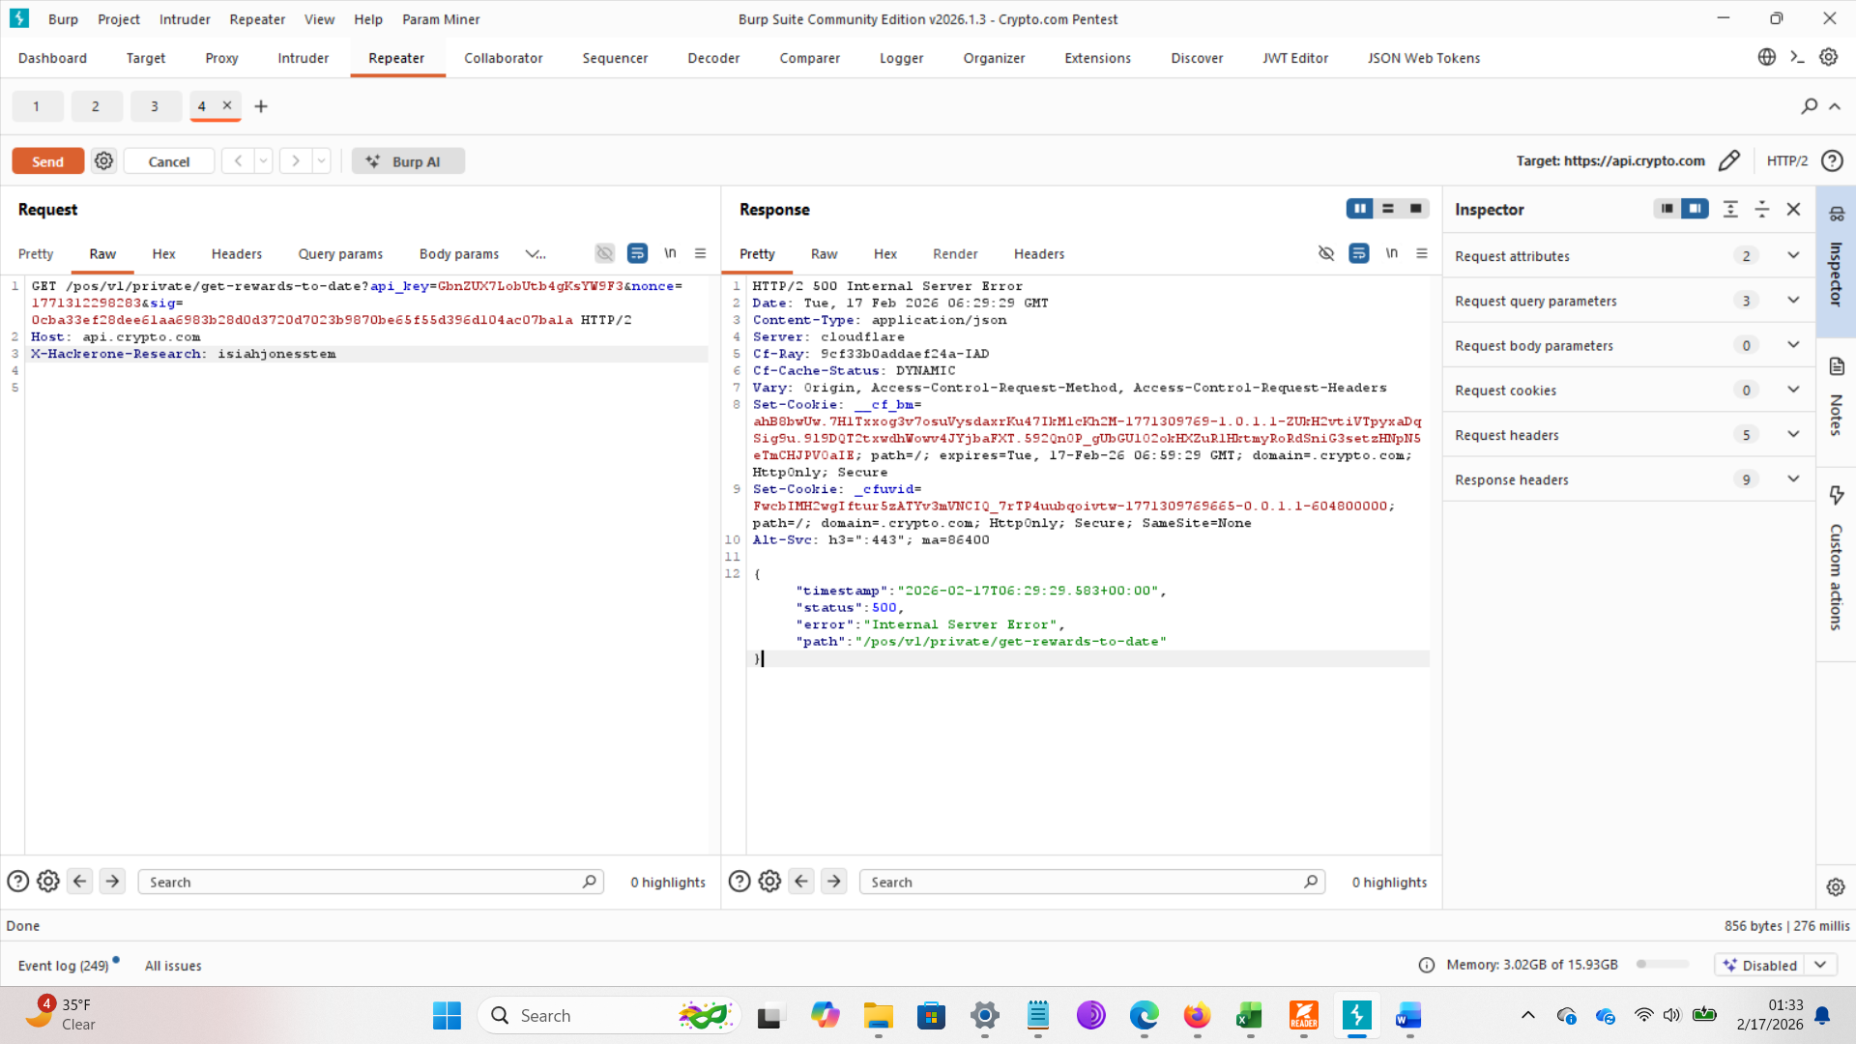

Recommended Fix:
Based on OWASP guidelines for handling exceptional conditions :
- Implement proper input validation:
  - Reject requests with unexpected HTTP methods (GET for POST-only endpoints) with a clear 405 Method Not Allowed response
  - Validate that authentication parameters are present in the expected location (request body, not query string)
- Enhance error handling:
python
# Example fix (conceptual)
try:
# Validate HTTP method
if request.method != 'POST':
return HttpResponse(
status=405,
content={"error": "Method not allowed. This endpoint requires POST."}
)

# Validate authentication parameters location
if 'api_key' in request.GET:
return HttpResponse(
status=400,
content={"error": "Authentication parameters must be in request body"}
)

# Process valid request
result = process_request(request)
return HttpResponse(status=200, content=result)

except Exception as e:
# Log full error internally
logger.error(f"Unexpected error: {e}", exc_info=True)

# Return generic error to client
return HttpResponse(
status=500,
content={"error": "An unexpected error occurred"}
)
- Apply OWASP A10:2025 mitigations :
  - Fail securely rather than failing open
  - Log exceptions with sufficient context for debugging (internally only)
  - Return generic error messages to clients
  - Implement circuit breakers for external dependencies
- Add rate limiting for this endpoint to prevent abuse
- Conduct security testing for all endpoints to identify similar exception handling issues

Supporting Material/References:
- Burp request/response file: 500-critical-find.burp (exported from Burp Repeater)
- Screenshot: 500-error-repeater shown in proof of concept section above.
- OWASP Top 10 2025 - A10:2025 Mishandling of Exceptional Conditions
- OWASP API Security Top 10 - API8 Security Misconfiguration
- OWASP Agentic AI - ASI05 Unexpected Code Execution
- Crypto.com API Documentation: https://exchange-docs.crypto.com/exchange/v1/rest-ws/index.html

Customer Impact:

- Denial of Service: An attacker could potentially trigger this error repeatedly, causing service degradation or outages for legitimate users
- Information Disclosure: The error response reveals internal server details and path information that could aid further attacks
- Data Integrity Risk: Unhandled exceptions could lead to partial transactions or inconsistent data states
- User Experience Degradation: Customers attempting to access their rewards information may receive error responses instead of expected data

Business Impact:
- Potential Server Takeover: In severe cases, improper exception handling can lead to memory corruption or remote code execution, as seen in similar vulnerabilities (CVE-2025-62164)
- Service Disruption: Repeated exploitation could lead to prolonged service outages affecting thousands of users
- Reputational Damage: Public disclosure of API instability erodes customer trust in the platform
- Regulatory Exposure: For financial platforms, service instability may violate uptime commitments or SLAs
- Meets Extreme Bounty Criteria: The potential for RCE or system compromise qualifies for the $1M+ loss threshold

